**Worksheet 3.3**

**Student Name: Ritika Rana UID:19BCA1126**

**Branch: UIC Section/Group: A/B**

**Semester: 6th Date of Performance:21-04-2022**

**Subject Name: Microprocessor interfacing lab Subject Code: CAP- 356**

1. **Aim/Overview of the practical:A memory location 3020H consist of data 80H. Write a program to shift left twice and store the result at 3022H**

**2. Task to be done: program to shift left**

**3. Hardware Required:8085 microprocessor kit**

**4. Program:**

**LDA 3020H**

**RAL**

**RAL**

**STA 3022H**

**HLT**

**5. Observations:**

**a.** LDA is used to load data into accumulator.

**b.** Each binary bit of the accumulator is rotated left by one position through the Carryflag

**6. Output:**

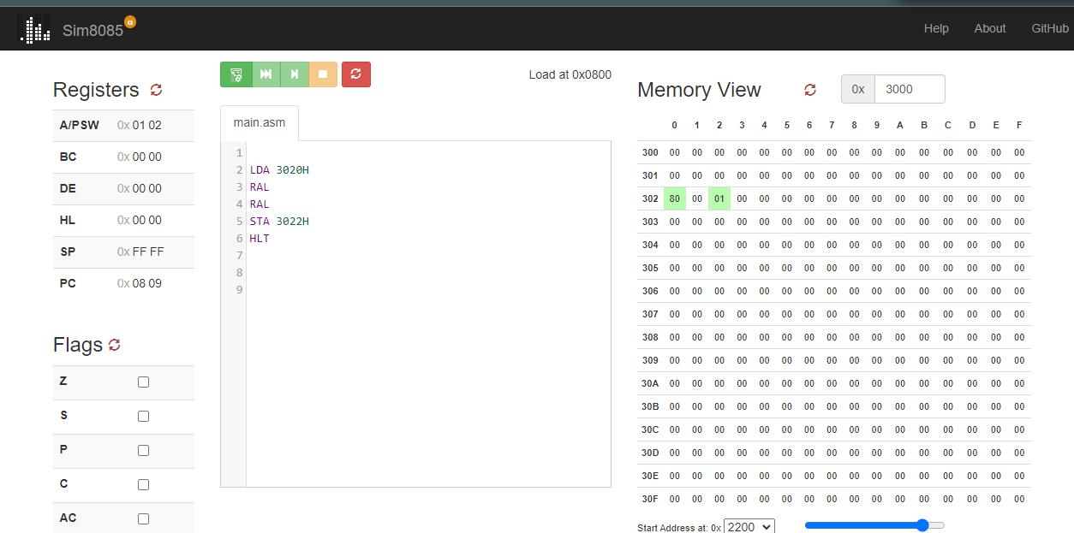

**7. Learning outcomes (What I have learnt):**

**1.**I have learned to shift a 2 8bit no. by one bitand left ,right rotation like rar,ral .

2. I have learned to use 8085 micrprocessor

3. we are working on this.sim8085.com

**ii ) Aim/Overview of the practical:** WAP in which a memory location 3020H consist of data

45H.Write a program to shift data right twice and store the result at 3021H**.**

1. **Task to be done:** Shifting of right.
2. **Hardware Required:** Microprocessor 8085 simululator

4.Program:

LDA3020H;RAR;

RAR;

STA 3021H; HLT;

1. **Observations:**
   * RAR means rotate accumulator to the right.
2. **Calculations:(A)**

**Input:**

At3020Htaking45asinputdata 45Asbinary01000101

Shiftingright1sttime=001000101

Shiftingright2ndtime=10010001=91

1. **Output:**

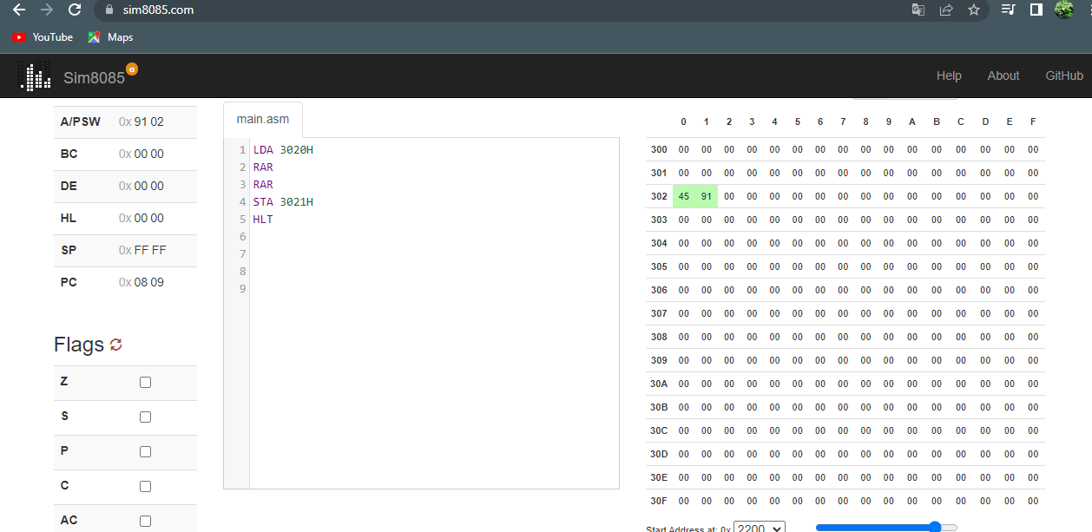

1. **Learning out comes(What have learnt):**
   1. Use of RAR instruction
   2. BasicoperationsonMicroprocessor8085
   3. Use of instructions on microprocessor.
   4. Shifting of 8bit number.

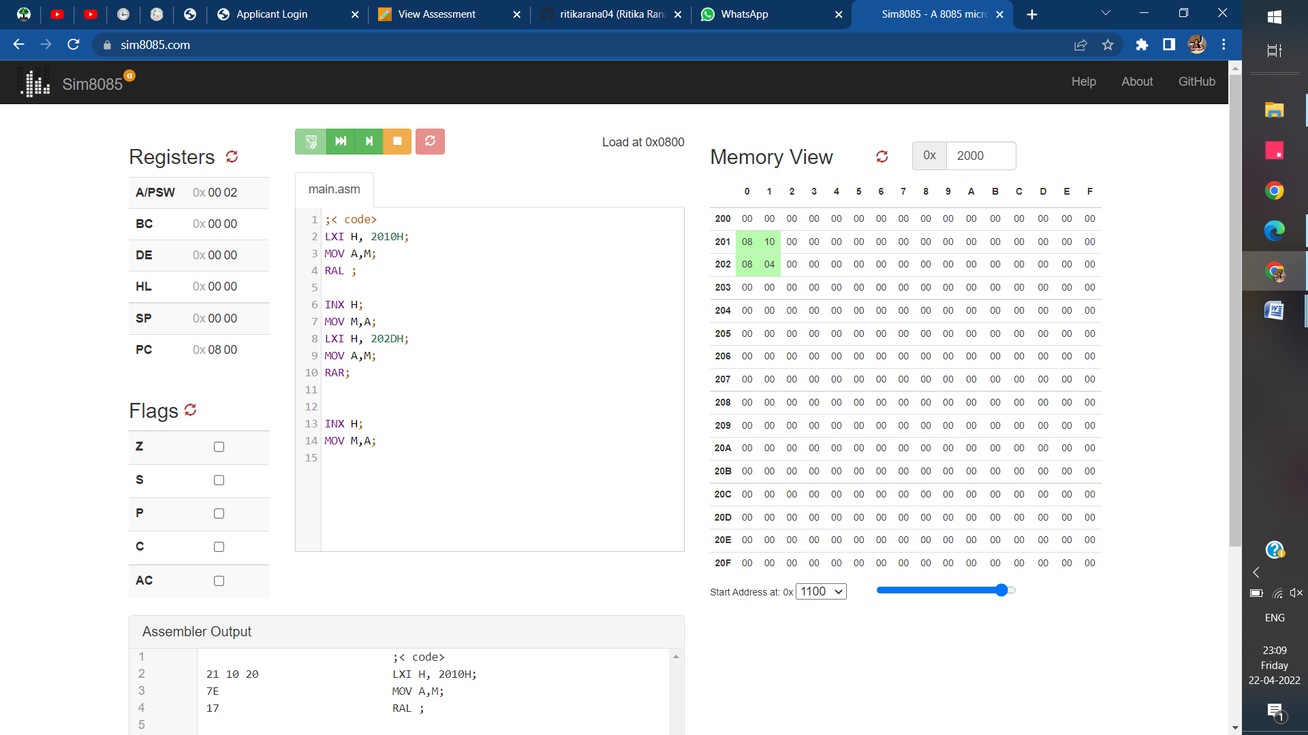

**Evaluation Grid (To be created as per the SOP and Assessment guidelines by the faculty):**

|  |  |  |  |
| --- | --- | --- | --- |
| Sr. No. | Parameters | Marks Obtained | Maximum Marks |
| 1. | Worksheet |  | 10 |
| 2. | Post lab question |  | 5 |
| 3. | Pree lab question |  | 5 |
|  |  |  |  |